Numerical Outlier Filtering & Blendshape Aggregation
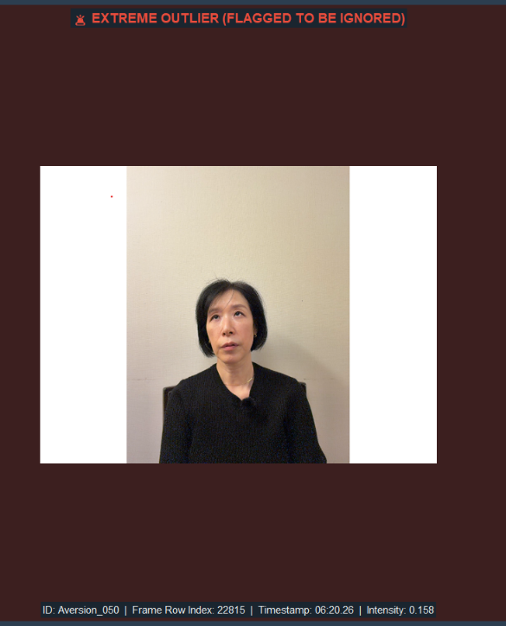
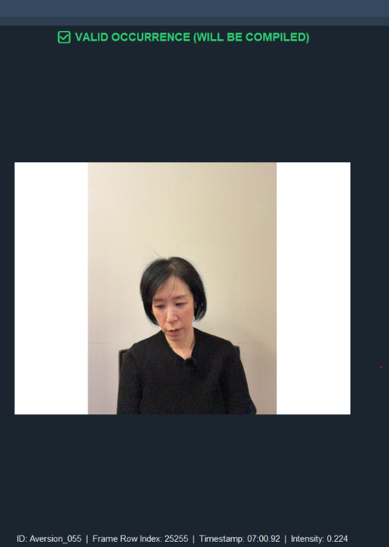
Our expression detection pipeline was not robust to false negatives and human errors such as participant looking away or blinking. It we calculate a naïve average across all the data, these bad frames contaminate the cohort profile. Thus before we aggregate the blendshapes, we introduce a graphical interface (frames_filtering.py) to scrub through trials manually, identifying the contaminated or outlier sequences and log them to a master checklist. We are able to iterate through each group and expression through this GUI. An example of an outlier is shown below:

Figure 1. Aversion expression for pr_10 flagged because it is detected even though the candidate is concentrating
Once the manual scrubbing phase is complete, the blendshape averaging code perform the math. The script access the master checklist (outlier_log.csv), and extracts the unique participant and event ID tracking signatures. The engine transverses the data tree and targets the CSV files containing the numerical blendshape tracking coefficient for every valid event. As the csv file is read, it checks the file’s meatdata against the outlier signature list. If a match is found, the trial is deleted from the memory instantly. For every clean trial, the script calculates the arithmetic mean of each blendshape channel across the entire duration of that event, reducing a fluctuating time series down to a single stable vector. In the end, the script groupings are averaged again to form a master baseline profile for the entire cohort and is exported as a unified multi-sheet workbook.
We use our muscle_activation_visualization.py script to transform raw numerical blendshape excel data into intuitive, auditable horizontal bar charts. The script targets the clean, non-outlier data in the average worksheet tab, loops through the eight behavioral expressions, and generated isolated scales strictly from 0.0 to 1.0. As a result we are able to visualize which specific facial muscle channels drive each target emotional state and the difference in the activation of these muscles for the same expression between our cohorts. An example for positive social expression is shown below for both Group A and B and we see that Group B is less expressive for the same emotion defined by the same blendshapes:
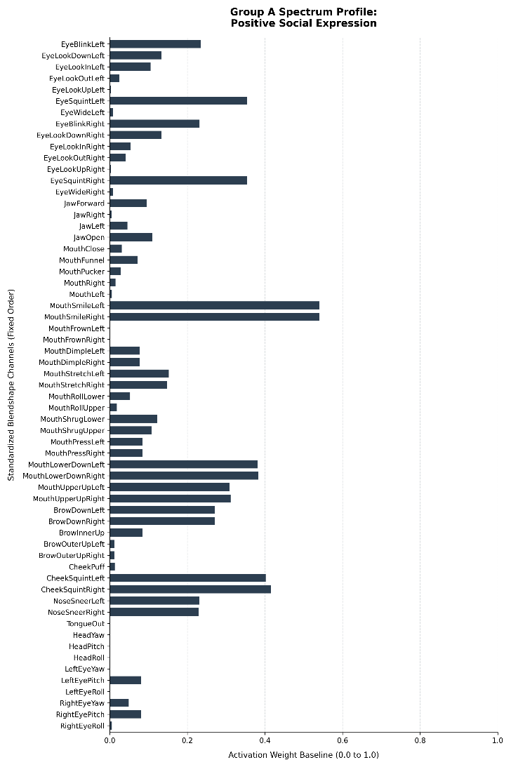
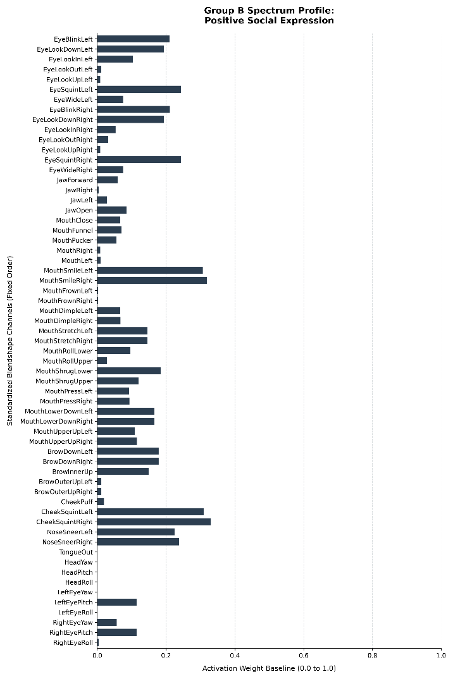

Figure 1. Average Blendshape activation for positive social expression for both groups

